 | IBMS EXPERIENTIAL ROUTE TO FELLOWSHIP APPLICATION FORM

PLEASE READ ‘GUIDANCE FOR APPLICANTS’ BEFORE COMPLETING THIS FORM.
APPLICATIONS RECEIVED WITHOUT THE FEE WILL BE RETURNED.

First Names: |  |  | Surname:
Title: |  |  | Suffix:
Gender: | Male | Female | Date of Birth:

IBMS Membership Grade (if current member) |  | IBMS Membership Number (if current member)

Home Address |  | Current Employment Address
Address Line 1 |  | Job Title
Address Line 2 |  | Company/Hospital
Address Line 3 |  | Address Line 1
Town |  | Town
County |  | County
Postcode |  | Postcode
Country |  | Country
Telephone Number |  | Telephone
Email |  | Email

Previous Employment Dates: to-from Company/Hospital Post held (grade & title)

Date | Company / Hospital | Post Held (Grade and Title)

Education: Copies of certificates should be sent with this application

Date Awarded | Awarding Body | Subject | Qualification

Please indicate your specialty (please tick or circle)

Clinical Chemistry | Cytology | Education | Medical Microbiology | Other:
Histopathology | Immunology | Virology | Blood Sciences
Parasistology | Serology | Genetics
Transfusion Science | Veterinary Science | Haematology

Do you have a specific responsibility for (please circle or tick):

Training | R&D | Safety | Other:
Quality | Advanced Practice | Management

Checklist: I enclose

Required | Enclosed / Completed Y/N | IBMS Check Received  Initial & Date | Outcome
A personal statement (Word Document, up to 1,500 words)
Up to date CV (max 4 pages)
Current organisation chart
Current job description
Copies of Education Certificates
A list of previous 2 years CPD activity
Applicant Signature
Verifier Signature
Declarations Completed
Fee (credit or debit card)

FOR IBMS USE ONLY:

Personal Supporting Statement for (Insert Name)
Maximum 1,500 Words
Please read ‘Guidance Notes for Candidates’ before completing this section
All sections are expandable
- Explain, with examples, how you have obtained a high level of specialist knowledge and crititcal awareness of current issues relevant to the delivery of your service

- Explain, with examples, how you have worked as an advanced level scientist or senior manager within a clinical laboratory setting
- Explain with examples, how you have worked in an autonomous role requiring judgement and leadership

- Explain with examples, how you are committed to a continual advancement of knowledge and your input into its application to service improvement and delivery

- Explain with examples, how you have made a wider contribution to the development and promotion of your profession

Declarations
Are you aware that claims of professional negligence, error or omission have ever been made against you?
No Yes
Are you aware of any circumstances, allegations or incidents which may give rise to a claim against you for professional negligence, error or omission?
No Yes
If yes to either of the above, please provide full details in an accompanying letter.
I declare that I am eligible for the selected category of membership and that I will notify the IBMS if my name is removed from the Health and Care Professions Council (if applicable). Please tick

I acknowledge that it is my responsibility to inform the IBMS if there is any change to my personal or workplace details. Please tick

I have read, understood and agree to abide by the Institute’s Code of Conduct (available in membership pack, or by emailing mc@ibms.org) Please tick

We like to keep you informed about IBMS services, campaigns, events, publications and new initiatives. It is also important for us to find out your views on a range of issues. This may be by post, telephone or electronic mail. Should you not want us to do this, please tick this box.

If you would like to receive information about biomedical science from third party organistaions, Plese please tick this box
I, the undersigned apply for membership of the IBMS and declare that the foregoing statements are correct.
Please tick this box
Signature __________________________________________ Date ______________________________
Applicant Signature
I wish to apply for Fellowship via the IBMS Experiential Route. I declare that the information I have given with this application is, to the best of my knowledge accurate and true.
Sign: |  |  |  |  |  |  | IBMS Membership Number:
Print Name: |  |  |  |  |  |  | Date:

Verifier Signature
I confirm that information as provided in this application is, to the best of my knowledge accurate and true.

Sign:
Print Name: |  |  |  |  |  | Email/
Relationship to Applicant ---
RETURN ADDRESS Institute of Biomedical Science, Membership Department, 12 Coldbath Square, London, EC1R 5HL
Tel: + 44 (O) 20 7713 0214 E: mc@ibms.org

Experiential Route to Fellowship Application Fee:

The fee to assess the application is £325. This fee is non-refundable and is payable by Credit or Debit Card only.

If successful, an annual Fellowship subscription fee and the one-off mandtaory registration fee of £20 will also apply. To view, current subscription fees, see

https://www.ibms.org/join/membership-fees/

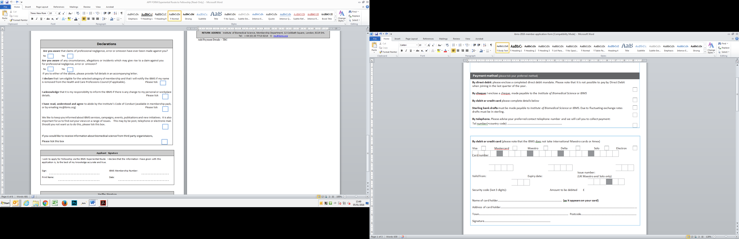
In providing IBMS with the information requested you are consenting to its use as indicated in the IBMS Privacy Notice. Further information can be found on the IBMS website at https://www.ibms.org/privacy/

Post Assessment to be completed by IBMS Membership Manager

Approved Y/N
Passed to Membership
Integra Updated
If unsuccessful, feedback provided

