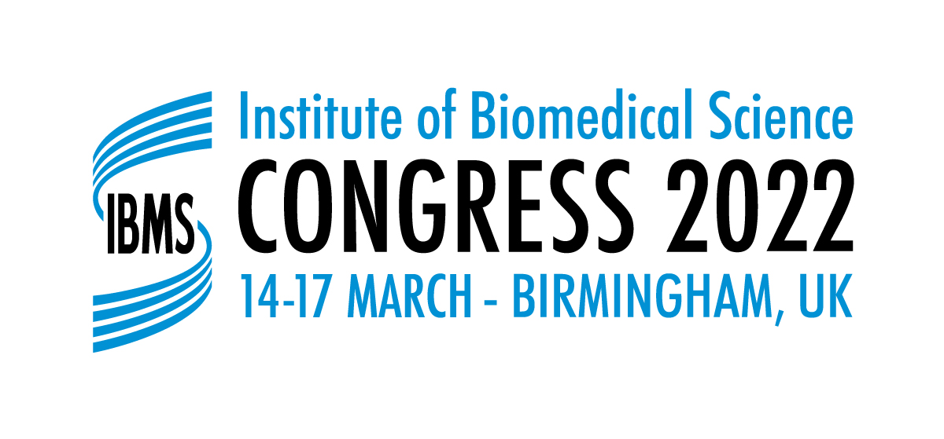 | POSTER APPLICATION FORM

12 Coldbath Square, London EC1R 5HL, Tel: 020 7713 0214, Fax: 020 7837 9658, Website: https://congress.ibms.org/home/

Please complete all sections of the application form. The completed form should be sent to congress@ibms.org . Incomplete application forms will be returned to the applicant. Deadline for receipt of application is 30 July 2021.

Posters must be presented on the allocated day, as stated in the programme. In the event that the applicant is unable to present the poster on the specified day, please email congress@ibms.org with regard to any alternative arrangements that have been made for the poster to be displayed and presented on that day.

The title of all shortlisted presentations will be published on the Congress area of the IBMS website prior to Congress. Successful applicants must email a pdf copy of the final poster for upload to the IBMS Website. These posters will be published after the event.
Your details
Surname | Title (Dr/Mr/Mrs/Miss/Ms/Other)
Forename(s) | IBMS membership no. (if applicable)
Highest qualification
Address for correspondence
Address
Postcode | Country
Tel number
Email address
(this is the address that your confirmation of acceptance will be sent)
Discipline
Details of submission
Presentation Title
Main Author
Co-authors (maximum of 4)
Abstract (please see the website for guidance on writing an abstract):

Has this poster been presented elsewhere? If yes please provide details below:

Signature |  | Date

In providing IBMS with the information requested you are consenting to its use as indicated in the IBMS Privacy Notice. Further information can be found on the IBMS Congress website at https://congress.ibms.org/privacy-notice/

