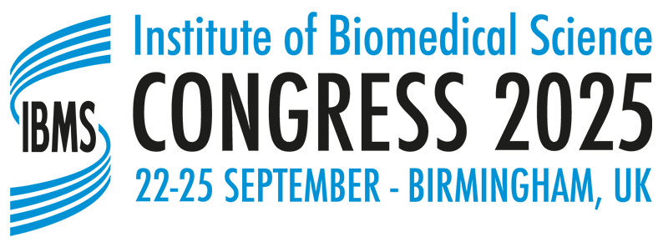
POSTER APPLICATION FORM
Please complete all sections of the application form. The completed form should be sent to congress@ibms.org . Incomplete application forms will be returned to the applicant. Deadline for receipt of application is 30 April 2025.

Posters must be presented on the allocated day, as stated in the programme. In the event that the applicant is unable to present the poster on the specified day, please email congress@ibms.org with regard to any alternative arrangements that have been made for the poster to be displayed and presented on that day.

The title of all shortlisted presentations will be published on the Congress area of the IBMS website prior to Congress. Successful applicants must email a pdf copy of the final poster for upload to the IBMS Website. These posters will be published after the event.
Please contact the IBMS Congress Office at E: congress@ibms.org or T: 0207 713 0214 if you need any assistance.
Your details
Surname | Title (Dr/Mr/Mrs/Miss/Ms/Other)
Forename(s) | IBMS membership no. (if applicable)
Highest qualification
Employing Organisation or University if you are a student
Contact Details for correspondence
Tel number
Email address
(this is the address that your confirmation of acceptance will be sent)
Discipline
Details of submission
Poster Title
Main Author
Co-authors (maximum of 4)
Abstract (please see the website for guidance on writing an abstract and how your abstract will be assessed):

Has this work been published or accepted for publication? If yes, please provide details below:

Has this poster been presented elsewhere? If yes, please provide details below:

Signature |  | Date

In providing IBMS with the information requested you are consenting to its use as indicated in the IBMS Privacy Notice. Further information can be found on the IBMS Congress website at https://congress.ibms.org/privacy-notice/

In submitting an application form you are consenting for the abstract to be shared with the editorial team of the official journal of the IBMS, the British Journal of Biomedical Science, in order for the Editor to ascertain the suitability of the research for publication in the journal, should you wish to do so.

